**Proposal 3 - Toronto New Restaurant Location App**

**Team Members**

* Dong Yi Kim
* Saloni Gupta
* Sooyeon Kim
* Saif Gorges

**Intro**

We will be building on top of the previous projects which concern themselves with crime, income and ethnicity demographics and restaurant data in Toronto. The goal of this app will be to help restaurant owners decide where the best placement of a new restaurant would be. Our app will include graphs and charts which consider ethnicity, local competition, income, and crime per neighborhood to help determine whether a restaurant could potentially be profitable or not each neighborhood.

**Visualizations & Interactivity**

We will include the following types of visualizations in our app:

* Bar graphs

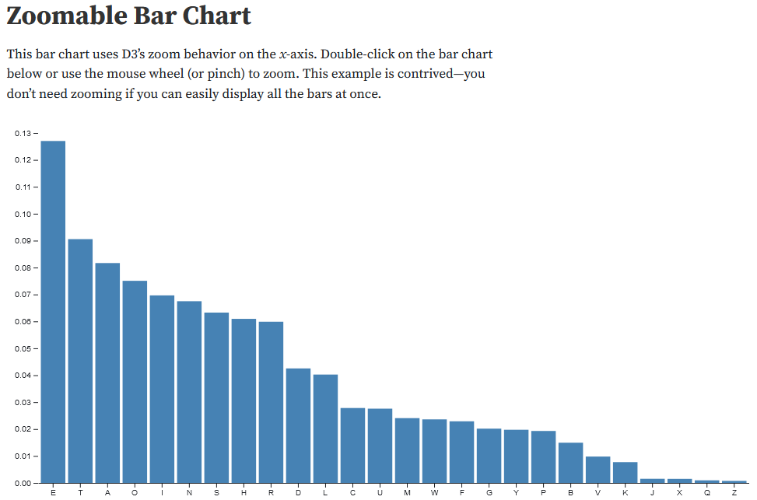

* Heat maps

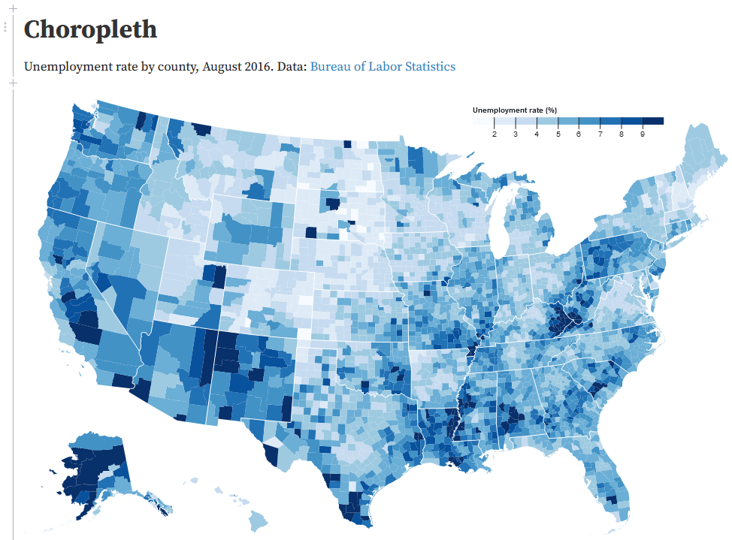

* Scatter plots

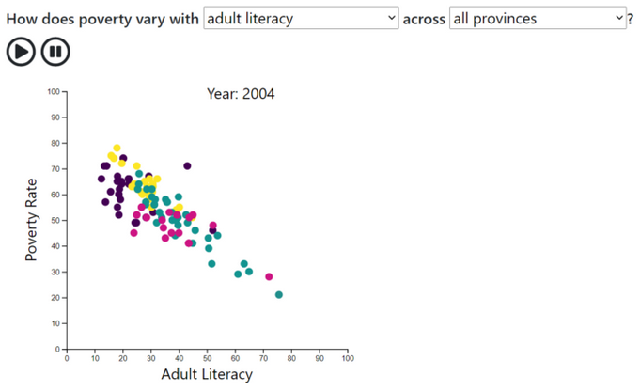

In order to give our clients the flexibility to explore the data and analyze based on their needs, we will include the following interactive features in our app:

* Dropdown menus
* Filters
* Textbox

**Links**

Repository

<https://github.com/saif-gorges/Restaurant-Data-App>